

**US Army Corps of Engineers**

**Afghanistan Engineer District**

AED Design Requirements:

Booster Pumps

Various Locations, Afghanistan

September 2009 Version 1.0

**TABLE OF CONTENTS**

AED DESIGN REQUIREMENTS FOR

BOOSTER PUMPS VARIOUS LOCATIONS, AFGHANISTAN

Section Page

**1. General 1**

**2. Booster Pump Layout 1**

**3. Booster Pump Selection 1**

a) System Head Curve 1 b) Static Head 1 c) Velocity Head 1 d) Friction Head 2 e) Equivalent Pipe Length 2 f) Hazen-Williams Coefficient 3 g) Pump Curve 3

**4. Booster Pump Valves 3**

**5. Booster Pump Controls 3**

a) Sensing and Measuring Elements 3 b) Comparison and Relaying Elements 4 c) Final Control Elements 4

**6. As-Builts 4**

Tables

Table 1. Minor Losses 2

Table 2. Hazen-Williams Coefficients 3

Examples

Example 1. Determine System Head Curve 4

**1. General**

The purpose of this document is to provide requirements to Contractors for any project requiring booster pump design and construction.

**2. Booster Pump Layout**

Booster pumps may be required anywhere in a water distribution system to increase the pressure in the pipeline. Booster pump stations are usually located remote from the main pump station or elevated storage, as in hilly topography where pressure zones are required. Booster pumps may be needed to handle peak flows in a distribution system which can otherwise handle the normal flow requirements. Booster pumps may be above ground or underground. Pump and control selection for in-line booster pumps will consider minimum suction pressure and automatic discharge cut-off pressure.

**3. Pump Selection**

**a) System Head Curve.** The first step in the pump selection process is to determine the system head curve for the piping system. The system head curve is determined from the total head (H) required in the piping system at varying flow rates. The total head (H) is the total discharge head (hd) minus the total suction head (hs).

H=hd-hs

The total discharge head (hd) is the sum of the static discharge head (hsd), the discharge velocity head (hvd) at the pump discharge flange and the friction head (hƒd) in the discharge line.

Hd=hsd+hvd+hƒd

The total suction head (hs) is the sum of the static suction head (hss) and the suction velocity head (hvs) at the pump suction flange minus the total friction head (hƒs) in the suction line.

Hs=hss+hvs+hƒs

Each type of head for the discharge and suction sides of the pump are calculated in the same manner.

**b) Static Head**. Static head is the vertical distance in meters from the pump inlet centerline to the highest point of free discharge. The static discharge head (hsd) is easily determined by simply subtracting the elevation at the centerline of the pump from the elevation of the highest discharge point in the system on the discharge side of the pump. The static suction head (hss) is the elevation difference between the centerline of the pump and the free water surface elevation of the supply reservoir. If the suction side of the pump is supplied by a pressurized water system, the static suction head will be the minimum pressure in the suction line at the pump flange, converted to head.

Theses value will remain constant for all flow rates.

**c) Velocity Head.** Velocity head is the head of a fluid as a result of its kinetic energy as shown by the following equation.

h =v2/2*g

v c

Where:

v=Q/A=flow velocity at the supply or discharge flanges of the pump (m/sec)

2

gc=gravitational constant=9.81 m/sec

Q=flow (m3/sec)

A= pipe area (m2)=π*(D2/4) D= pipe diameter (m).

The velocity head is a function of the fluid velocity which is related to the flow rate. The discharge velocity head (hvd) will need to be calculated for specific flow rates within the system. The suction velocity head (hvs) will need to be calculated for the minimum flow velocity at the pump flange on the suction side of the pump.

**d) Friction Head.** Friction head (hƒ) is the head required to overcome resistance to flow in the pipe and fittings. It is dependent upon the size, condition and type of pipe, number and type of pipe fittings, flow rate and nature of the liquid.

hf=L[(v/(kC))*(4/D)

0.63]1/0.54

Where:

L=equivalent length of pipe and fittings (m)

v=flow velocity in pipe (m/sec)

k=0.85.

C=Hazen-Williams coefficient. D=pipe diameter (m)

The discharge friction head (hƒd) will need to be calculated for specific flow rates within the system. Since the suction side of the pump will be supplied by a pressurized water system that will supply water to the pump, the suction friction head (hƒs) can be assumed to be zero.

**e) Equivalent Pipe Length.** Equivalent pipe length is the sum of the pipe length and the minor losses associated with all fittings along the pipe. Numerous minor loss tables are available which expressed the minor losses associated with various fittings as an equivalent pipe length. The designer should make sure that all minor losses are accounted for in the system and that the proper equivalent lengths are used for each type of fitting. A sample of equivalent length of straight pipe for various fitting of differing sizes id provided in Table 1.

**Table 1. Minor Losses**

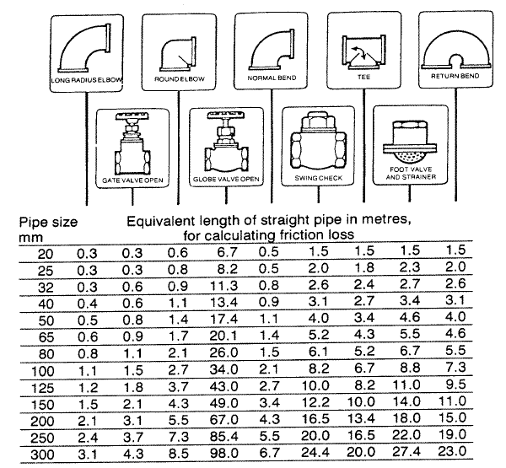

**f) Hazen-Williams Coefficient.** As with minor loss tables, numerous Hazen-Williams coefficient tables are available. The designer should select the appropriate coefficient based on the pipe material and age. A sample Hazen-Williams coefficient table is provided in Table 2.

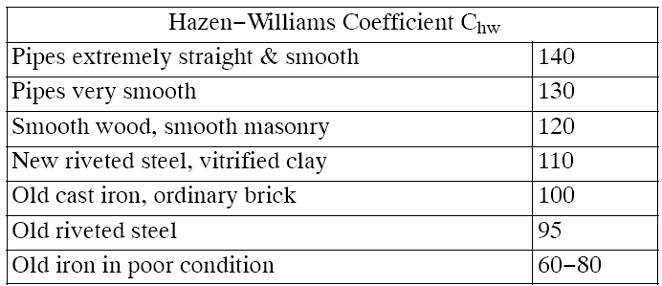

**g) Pump Curve.** With the system head curve defined, it is possible to select a pump to deliver the required capacity. Manufacturer’s published pump head-capacity curves will be used for this process. Since these pump head-capacity curves usually apply to a particular impeller and pump design, different manufacturers may show slightly different performance for the same type and size of pump. The system head curve is plotted on a manufacturer’s pump head-capacity curve to determine the operating characteristics of the pump. The point where the system head curve and the pump head- capacity curve intersect will be the theoretical point at which the pump will operate. If the intersection point of the system head curve and the pump head-capacity curve is not satisfactory for the intended purpose, a different pump must be selected.

**4. Booster Pump Valves**

Gate valves will be used on the suction and discharge sides of the booster pump to isolate the booster pump from the remainder of the distribution system for maintenance purposes. A check

valve will be provided between the pump and gate valve on the discharge side of the pump to protect the pump from excessive back pressure and to prevent liquid from running backward through the pump in case of a power failure. Pressure relief valves, commonly diaphragm activated globe or

angle type, will be installed on the discharge piping system for flow control and/or pressure regulation, and to protect pump equipment and piping system from excessive surge pressures. Pump control system valves range from single hand-operated valves to highly advances, automatic flow control or

pump speed control systems. In an unattended high head booster pump system the control valve

may have a controller to close automatically when the pump is stopped and to open once the pump has reached a specified speed after the pump is started. Control valves are installed to prevent surge pressures, which cause water hammer and high pressure. Designers should use their best judgment when selecting control valves. Minor losses for all valves on the discharge side of the pump should

be included in the system head curve calculations.

**5. Booster Pump Controls**

Pump controls will have the capacity to provide the desired flow rates and pressures, to provide protection from pump and piping system damage, and to serve as a tool to find system problems which may need operational adjustments, repair or maintenance. Control systems consist of the following:

Sensing and measuring elements (primary device). Comparison and relaying element (controller).

Final control element to produce the required change including an actuator to move control elements.

**a) Sensing and Measuring Elements.** Sensing and measuring elements consist of automatic pump control and valve operation equipment that will detect changes in the flow and emit a signal. The

most common sensing and measuring elements for booster pumps are pressure sensors and flow meters.

**b) Comparison and Relaying Elements.** Comparison and relaying elements are the transducers and transmitters, which are usually housed together in the controller which often is physically separated from the primary device and convert the signal from the sensing and measuring equipment into another signal medium that is necessary for actuation of the final control element.

**c) Final Control Elements.** For the final control element, valves and pumps serve for no-off control and modulating needs in the system. A control valve is a valve that modulates the flow through it to provide the desired pressure within the system. The term control valve means a specialized type of power-activated valve designed to modulate flow to meet system demands. The term pump as a final control element is a pump provided with automatic variable speed control drive to maintain an essentially fixed flow rate and for controlled flow rate increase/decrease at start/stop of pumping to minimize surge in the system. Variable speed pumps will be considered only for large pumps and

only if justified by an accurate economic analysis. Instrumentation for a booster station will supervise and monitor the routine operation of pumps, their drives and accessories to sustain a desired level of performance and reliability. Alarm situations will be identifies, such as low flow and low pressure, pump failure, power failure and low suction head (water loss). The selection of all booster pump controls should be based on the system layout and the designer’s experience. When possible, the designer should select a packaged booster pump system.

**6. Design Capacities.**

For installations with fewer than 400 persons, the capacity shall be based the installation wide, total fixture unit flow. For installations with greater than 400 persons, the capacity shall be based on the installation wide, total fixture unit flow or 2 times the average daily flow, whichever is greater. Three identical pumps shall be provided which are all sized to deliver 50% of the calculated capacity. Pumps shall automatically alternate to distribute wear and shall automatically turn on and off based on demand and system pressures. The total dynamic head (TDH) of the booster pumps shall be calculated to maintain a minimum, residual system pressure of 40 psi at the calculated capacity unless stated otherwise in the contract documents.

**7. As-Builts**

Upon completion of installing the booster pump system, The Contractor shall submit editable CAD format As-Built drawings. The drawing shall show the final product as it was installed in the field, with the exact dimensions, locations, materials used and any other changes made to the original

drawings. Refer to Contract Sections 01335 and 01780A of the specific project for additional details.

**Example – Booster Pump sizing and Selection**

Determine the system head curve for a flow range from 0.00 to 0.10 cubic meters per second.

Given:

Pump elevation=23.50 meters Discharge elevation=87.65 meters Static suction head=0.00 meters Pipe diameter=0.20 meters

Pipe length=700 meters

Hazen-Williams coefficient=130

Fittings:

1-Fully open gate valve

1-Swing check valve

3-Line flow flanged tees

Calculated:

1. Determine static discharge head (hsd) which is the discharge elevation minus the pump elevation.

hsd=87.65 meters-23.50 meters=64.15 meters.

2. Determine pipe area (A)=3.14159*(0.22/4)=0.0314 m2

3. Determine pipe velocity for variable flow rates.

Velocity (v)=flow/pipe area

2*gc

|  |  |  |  |
| --- | --- | --- | --- |
| 4. | Flow  0.00 | Velocity  0.00 |  |
| 0.02 | 0.64 |
| 0.04 | 1.27 |
| 0.06 | 1.91 |
| 0.08 | 2.55 |
| 0.10 | 3.18 |
| Determin | e the discharge velocity hea | 2  d (hvd)=v / |
| Flow  0.00 | hvd  0.00 |  |
| 0.02 | 0.02 |  |
| 0.04 | 0.08 |  |
| 0.06 | 0.19 |  |
| 0.08 | 0.33 |  |
| 0.10 | 0.52 |  |
| 5. | Determin | e the minor losses: |  |

1-Fully open gate valve @ 0.15=0.15 meters

1-Swing check valve @ 2.00=2.00 meters

3- Line flow flanges tees @ 0.20=0.60 meters

Total minor losses=2.75 meters

6. Determine equivalent pipe length which is the sum of the pipe length plus the minor losses.

Equivalent pipe length=700 meters+2.75 meters=702.75 meters.

7. Determine the discharge friction head hƒd)=L[(v/(kC))*(4/D)

0.63]1/0.54

|  |  |  |
| --- | --- | --- |
| Flow  0.00 | 0.00 | hƒd |
| 0.02 | 1.65 |  |
| 0.04 | 5.96 |  |
| 0.06 | 12.62 |  |
| 0.08 | 21.50 |  |
| 0.10 | 32.50 |  |

8. Determine total discharge head (hd) which is the sum of the static discharge head, discharge velocity head and the discharge friction head.

|  |  |  |  |  |  |  |  |  |
| --- | --- | --- | --- | --- | --- | --- | --- | --- |
| Flow  0.00 | + | hsd  64.15 | + | hvd  0.00 | + | hƒd  0.00 | = | hd  64.15 |
| 0.02 |  | 64.15 |  | 0.02 |  | 1.65 |  | 65.82 |
| 0.04 |  | 64.15 |  | 0.08 |  | 5.96 |  | 70.19 |
| 0.06 |  | 64.15 |  | 0.19 |  | 12.62 | 76.96 | |
| 0.08 |  | 64.15 |  | 0.33 |  | 21.50 | 85.98 | |
| 0.10 |  | 64.15 |  | 0.52 |  | 32.50 | 97.17 | |

9. Plot the system head curve.

**SYSTEM HEAD CURVE**

120.00

100.00

80.00

60.00

**Total Head (m)**

40.00

20.00

0.00

0.00 0.02 0.04 0.06 0.08 0.10 0.12

**Flow (cu. m/sec.)**